Illinois State University School of Information Technology
IT 276 A. Rezgui

Lab 11 - IPv4 – Packet Format – Part 1

Student:___Kristian Neilands____

Recall that a typical 20-byte IPv4 header looks like this:

Version | HLEN |  | Service Type | Total Length
Identification |  |  |  | Flags | Fragment Offset
TTL |  | Protocol |  | Header Checksum
Source IP address
Destination IP address

In this lab, we will ignore the shaded fields.

- Start a Wireshark capture and then, using your favorite browser, access:

http://gaia.cs.umass.edu

Use this text in the Wireshark’s filter bar: http && ip.addr==128.119.245.12

Your capture should like this:

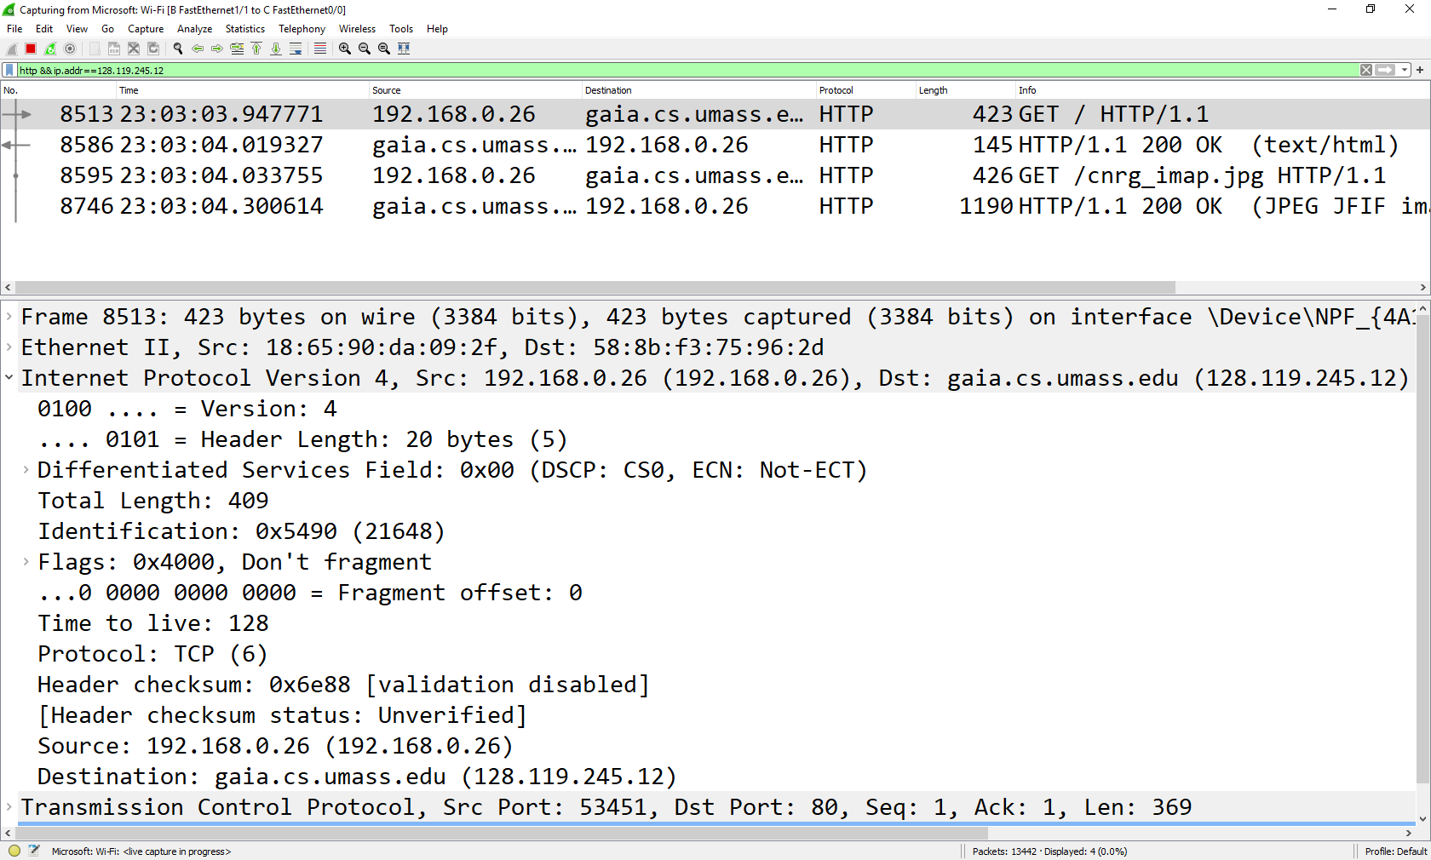

- For the two first IP packets, fill out the fields of their IP headers:

Packet 1 (HTTP GET request)

4 | 20 |  |  | 478
 |  | TCP (6)
10.135.23.56
128.119.245.12

Packet 2 (HTTP response)

4 | 20 |  |  | 279
 |  | TCP (6)
128.119.245.12
10.145.23.56

- Which version of IP are we using?
IPv4

- What is the type of segment inside the first two IP packets: a TCP segment or a UDP segment?
TCP Segment

- How do you know? (without looking at the transport layer in Wireshark)
It says it underneath the protocol.

- For the two first packets, fill out the following table:

 | # of bytes of TCP payload | # of bytes in TCP header | # of bytes in IPv4 header | Total size of IPv4 packet
Packet 1 (GET) | 438 | 20 | 20 | 478
Packet 2 (response) | 239 | 20 | 20 | 279

